~~Personal Insurance, Inc.~~

Shelly Cashman Access 2019 | Module 6: SAM Project 1a



~~Advanced Report Techniques~~

# ~~GETTING STARTED~~

* ~~Open the file~~ **~~SC_AC19_6a_~~*~~FirstLastName~~*~~_1.accdb~~**~~, available for download from the SAM website.~~
* ~~Save the file as~~ **~~SC_AC19_6a_~~*~~FirstLastName~~*~~_2.accdb~~** ~~by changing the “1” to a “2”.~~

~~If you do not see the .accdb file extension in the Save As dialog box, do not type it. The program will add the file extension for you automatically.~~

* ~~To complete this SAM Project, you will also need to download and save the following data files from the SAM website onto your computer:~~

~~Support_AC19_6a_Claims.txt~~

* ~~Open the~~ **~~_GradingInfoTable~~** ~~table and ensure that your first and last name is displayed as the first record in the table. If the table does not contain your name, delete the file and download a new copy from the SAM website.~~
* ~~PROJECT STEPS~~

1. ~~Personal Insurance, Inc. is a national company that insures homeowners and renters. As a regional manager, you need to be able to create professional reports for employees and for entities outside the company.   
     
   Import the data from the file~~ **~~Support_AC19_6a_Claims.txt~~**~~, and then append the records to the~~ *~~Claims~~* ~~table. The text file is a delimited file with a comma separating each of the six fields. Do not create a new table, and do not save the import steps.~~
2. ~~Open the~~ *~~Regional Customer~~**~~List~~**~~Report~~* ~~in Design View, and then complete the following tasks:~~
   1. ~~Add the current date and time to the Report Header section.~~
   2. ~~In the Date and Time dialog box, use the option button to select the second date format (e.g., 01-Aug-19) and the second time format (e.g., 4:19 PM).~~
   3. ~~Resize the report so that the right boundary of the report is approximately at the~~ **~~8.5"~~** ~~mark on the horizontal ruler.  
        
      Save the report without closing it.~~
3. ~~With the~~ *~~Regional Customer List~~**~~Report~~* ~~still open in Design View, complete the following tasks:~~
   1. ~~Select the Region Header, and then display the Property Sheet for this section.~~
   2. ~~Change the Repeat Section property to~~ **~~Yes~~**~~.~~
   3. ~~Change the Force New Page Property to~~ **~~Before Section~~**~~.   
        
      Save and close the report.~~
4. ~~Modify the~~ *~~Claims by ClaimRep Report~~* ~~by completing the following tasks:~~
   1. ~~Open the~~ *~~Claims by ClaimRep Report~~* ~~in Design View.~~
   2. ~~Open the field list for the report.~~
   3. ~~Add the~~ **~~LastName~~** ~~field to the ClaimRepNumber Header section of the report so that the left edge of the control is at the 5" mark on the horizontal ruler. The left edge of the label is just to the left of the 4" mark on the horizontal ruler. (~~*~~Hint~~*~~: You may need to reposition and resize the~~ *~~LastName~~* ~~control and its label after inserting it into the report.)  
        
      Confirm that the report matches Figure 1, and then save the report without closing it.~~
5. ~~With the~~ *~~Claims by ClaimRep Report~~* ~~still open in Design View, complete the following tasks:~~
   1. ~~Select the~~ *~~ClaimID~~*~~,~~ *~~CustomerID~~*~~,~~ *~~PolicyNumber~~*~~,~~ *~~ClaimAmount~~*~~, and~~ *~~Paid~~* ~~controls simultaneously.~~
   2. ~~Group the controls.~~
   3. ~~Resize the controls by dragging their right edge to the 4" mark on the ruler.~~
   4. **~~Bold~~** ~~the controls.  
        
      Confirm that the report matches Figure 1, and then save and close the~~ *~~Claims by ClaimRep Report~~*~~.~~

* ~~Figure 1: Claims by ClaimRep Report – Design View~~

~~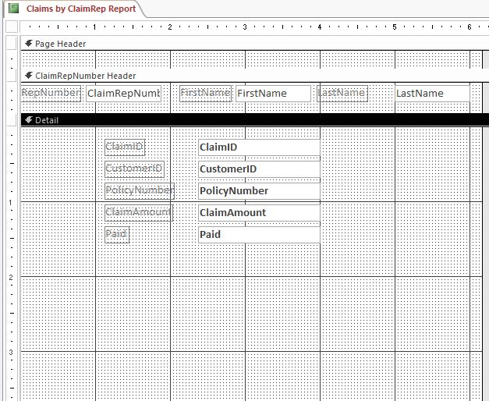~~

1. ~~Modify the~~ *~~Homeowners Coverage Report~~* ~~by completing the following tasks:~~
   1. ~~Open the~~ *~~Homeowners Coverage Report~~* ~~in Design View.~~
   2. ~~Change the~~ *~~Text11~~* ~~label in the Page Header section using~~ **~~TotalCoverage~~** ~~as the new label name.~~
   3. ~~Format the text box control in the Detail section containing the =[Liability]+[PropertyDamage] calculation so that it displays with the~~ **~~Currency~~** ~~number format and two decimal places.  
        
      Save the~~ *~~Homeowners Coverage Report~~*~~, switch to Report View, confirm your report matches Figure 2, and then close the report.~~

* ~~Figure 2: Homeowners Coverage Report—Report View~~

~~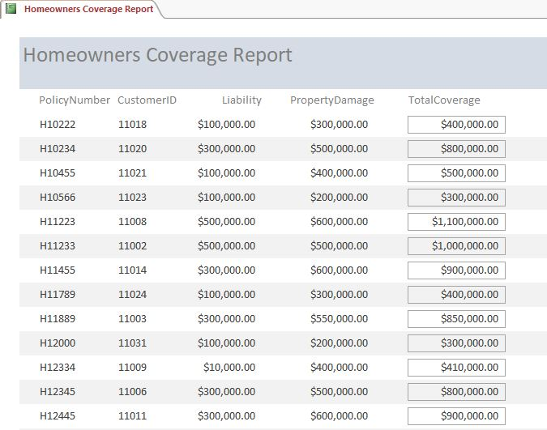~~

1. ~~Open the~~ *~~Basic Umbrella Policy List~~**~~Report~~* ~~in Design View, and then change the Alternate Back Color property for the Detail section to~~ **~~No Color~~**~~. Save and close the report.~~
2. ~~Open the~~ *~~Homeowners Premium Report~~* ~~in Design View, and then use the Subform/Subreport Wizard to add a subreport with the following options:~~
   1. ~~Add the subreport below the~~ *~~Address~~* ~~label in the Detail section, at approximately the~~ **~~1"~~** ~~mark on the vertical ruler.~~
   2. ~~Use the~~ *~~Homeowners~~* ~~table as the source of the subreport.~~
   3. ~~Select the~~ *~~PolicyNumber~~*~~,~~ *~~PropertyDamage~~*~~, and~~ *~~Premium~~* ~~fields (in that order) from the~~ *~~Homeowners~~* ~~table to add to the subreport.~~
   4. ~~Ensure that the~~ **~~Choose from a list~~** ~~option button is selected, and accept the default link~~ **~~Show Homeowners for each record in Customers using CustomerID~~** ~~for the subreport.~~
   5. ~~Save the subreport as~~ **~~Homeowners subreport~~** ~~(which is the default name). (~~*~~Hint~~*~~: The width of the subreport may expand the width of the report. Do not manually adjust the width.)~~
   6. ~~Delete the label associated with the subreport.  
        
      Save the~~ *~~Homeowners Premium Report~~*~~, switch to Report View, confirm your report matches Figure 3, and then close the report.~~

* ~~Figure 3: Homeowners Premium Report—Report View~~

~~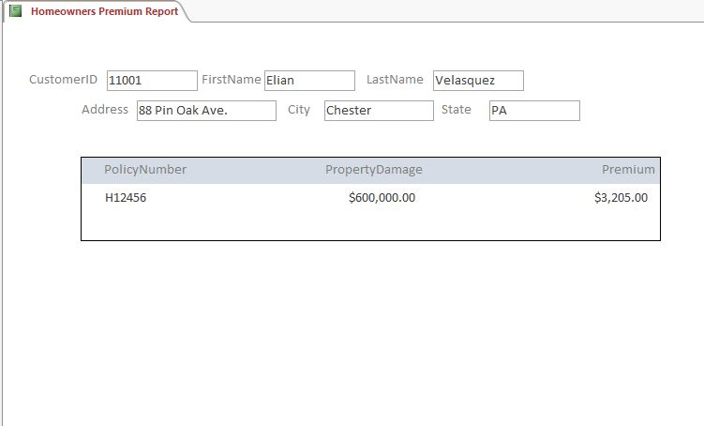~~

1. ~~Open the~~ *~~Customers by State Report~~* ~~in Design View, and then modify the report by completing the following tasks:~~
   1. ~~Resize the width of the report as shown in Figure 4. (~~*~~Hint~~*~~: The right border of the report is at the~~ **~~8"~~** ~~mark on the horizontal ruler.)~~
   2. ~~Move the~~ *~~PostalCode~~* ~~label and control so that it appears under the~~ *~~City~~* ~~control in the approximate location shown in Figure 4. (~~*~~Hint~~*~~: Align the bottom of the label and control with the~~ **~~2"~~** ~~mark on the vertical ruler.)~~
   3. ~~Select the~~ *~~Region~~*~~,~~ *~~PhoneNumber~~*~~, and~~ *~~DateOfBirth~~* ~~controls simultaneously. Do not select the labels.~~
   4. ~~Align the controls to the left as shown in Figure 4.  
        
      Confirm that the report matches Figure 4, and then save and close the~~ *~~Customers by State Report~~*~~.~~

* ~~Figure 4: Customers by State Report—Design View~~

~~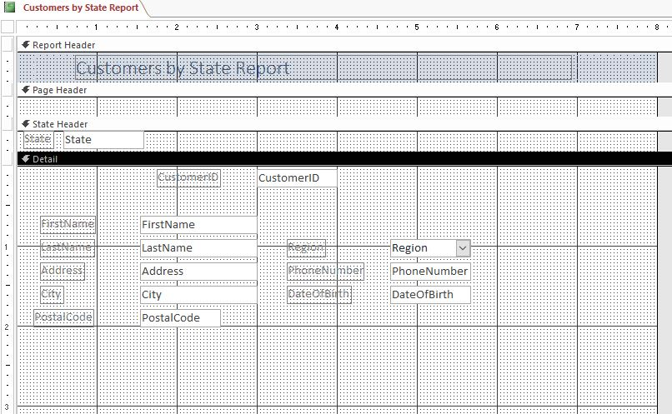~~

1. ~~Open the~~ *~~Customer Address List~~**~~Report~~* ~~in Design View, and then modify the report by completing the following tasks:~~
   1. ~~Select all labels in the Page Header section.~~
   2. **~~Bold~~** ~~the labels.~~
   3. ~~Select the~~ *~~Address~~* ~~control in the Detail section, and then change the Can Grow property to~~ **~~Yes~~**~~.~~
   4. ~~Resize the Detail section of the report by dragging the lower boundary of the section to just below the controls in the report, at approximately the .5" mark on the vertical ruler for the Detail section.  
        
      Confirm that the report matches Figure 5, and then save and close the~~ *~~Customer Address List~~*~~.~~

* ~~Figure 5: Customer Address List—Design View~~

~~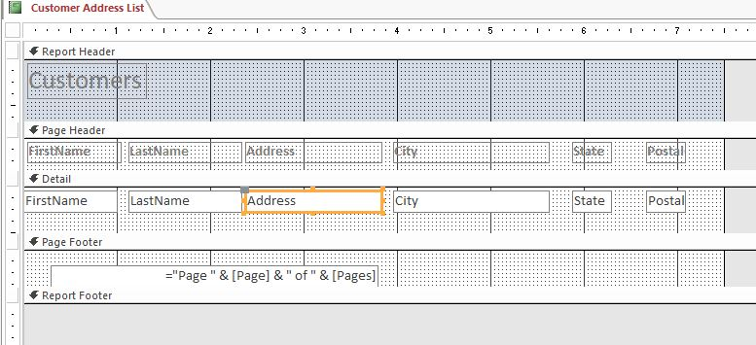~~

1. ~~Modify the~~ *~~Renters Premium List~~**~~Report~~* ~~by performing the following tasks:~~
   1. ~~Open the~~ *~~Renters Premium List~~**~~Report~~* ~~in Design View.~~
   2. ~~Use the Group, Sort, and Total pane to add a footer section to the~~ *~~Group on CustomerID~~* ~~section.~~
   3. ~~Add a text box control in the CustomerID Footer section.~~
   4. ~~Convert the text box control into a calculated control that averages the~~ *~~Premium~~* ~~field. (~~*~~Hint~~*~~: Your control should contain the formula =Avg([Premium]).)~~
   5. ~~Format the control so that it displays with the~~ **~~Currency~~** ~~number format and two decimal places.~~
   6. ~~Change the label using~~ **~~Average Premium~~** ~~as the label name.~~
   7. ~~Reposition the control and its label to the approximate location shown in Figure 6. (~~*~~Hint~~*~~: The left edge of the text box should be located at the 5" mark on the horizontal ruler.)  
        
      Confirm that the report matches Figure 6, and then save and close the~~ *~~Renters Premium List~~*~~.~~

* ~~Figure 6: Renters Premium List—Design View~~

~~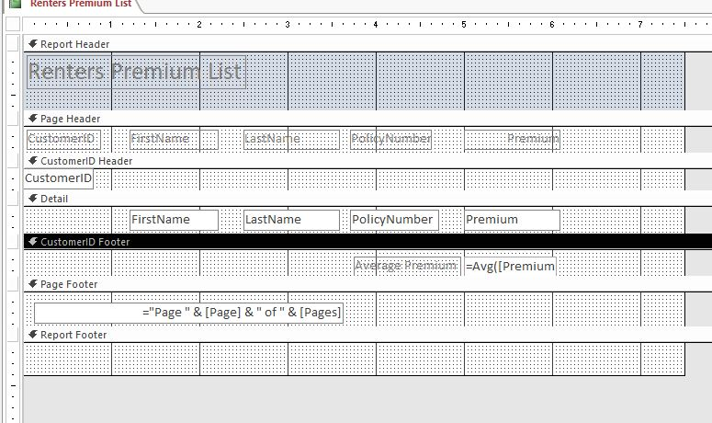~~

1. ~~Create a new blank report in Design View, and then complete the following tasks:~~
   1. ~~Open the Property Sheet for the report, and then apply the Record Source for the report to the~~ *~~Claims~~* ~~table.~~
   2. ~~Save the report with the name~~ **~~Basic~~****~~Claims Report~~**~~, but do not close the report.~~
   3. ~~Add the~~ *~~ClaimID~~*~~,~~ *~~CustomerID~~*~~, and~~ *~~PolicyNumber~~* ~~fields to the report and then reposition them so that the left edges of the three controls are at the 3" mark on the horizontal ruler and only a single dotted line separates the labels and controls vertically.~~
   4. ~~Add the title~~ **~~Basic~~****~~Claims Report~~** ~~to the Report Header section.~~
   5. ~~Add page numbers to the report at the Top of Page (Header) position, using the~~ **~~Page N of M~~** ~~format and~~ **~~Right~~** ~~alignment.  
        
      Confirm that the report matches Figure 7, and then save and close the~~ *~~Basic Claims Report~~*~~.~~

* ~~Figure 7: Basic Claims Report—Design View~~

~~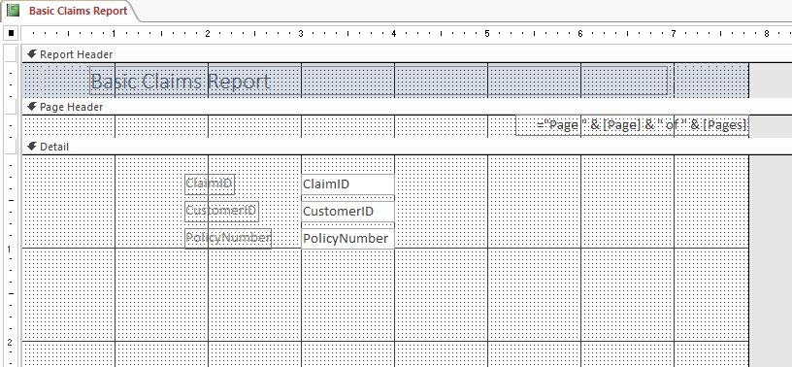~~

1. ~~Open the~~ *~~NE Homeowners by State Report~~* ~~in Design View. Group the report by the~~ *~~State~~* ~~field, and then sort the report by the~~ *~~CustomerID~~* ~~field in~~ **~~ascending~~** ~~order. Do not add any additional grouping or sorting options to the report. Save and close the~~ *~~NE Homeowners by State Report~~*~~.~~ *~~(Hint~~*~~: This report does not contain any fields.)~~
2. ~~Modify the~~ *~~Claims Total Report~~* ~~by performing these tasks:~~
   1. ~~Open the~~ *~~Claims Total Report~~* ~~in Design View.~~
   2. ~~Add a text box control to the Report Footer section. The left edge of the control (not the label) is at the 5" mark on the horizontal ruler.~~
   3. ~~Convert the text box control into a calculated control that sums the~~ *~~ClaimAmount~~* ~~field. (~~*~~Hint~~*~~: Your control should contain the formula =Sum([ClaimAmount]).)~~
   4. ~~Format the control so that it displays with the~~ **~~Currency~~** ~~number format and zero decimal places.~~
   5. ~~Change the label using~~ **~~Total~~** ~~as the new label name.~~
   6. ~~If necessary, reposition the control and its label so that the left edge of the text box is located at the 5" mark on the horizontal ruler.  
      Confirm that the report matches Figure 8, and then save and close the~~ *~~Claims Total Report~~*~~.~~

* ~~Figure 8: Claims Total Report—Design View~~

~~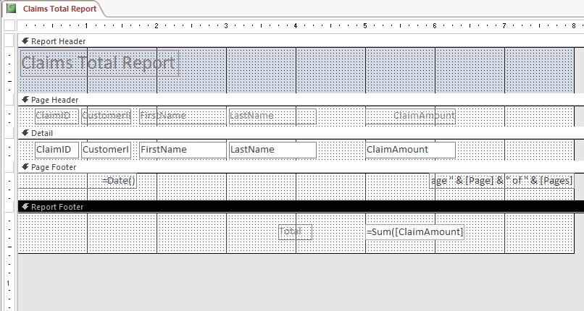~~

~~Save and close any open objects in your database. Compact and repair your database, close it, and then exit Access. Follow the directions on the SAM website to submit your completed project.~~